Website Project Proposal
Organization Name: Hope Hair & Beauty Salon
- Organization Overview
Hope Hair & Beauty Salon is a modern beauty salon founded in 2015 in Polokwane. It specializes in professional hair care, styling, nail services, facials and beauty treatments for all hair types and skin tones.
Mission: To provide high-quality, affordable beauty services that enhance clients’ confidence while creating a welcoming and relaxing environment.
Vision: To become the leading hair and beauty salon in Polokwane, known for skilled stylists, excellent customer care and modern techniques.
Target audience: Local women and men, working professionals, students and clients seeking special-occasion styling (ages 18–55).
- Website Goals and Objectives
The website will act as the main digital storefront. Goals include:
- Increase website traffic by at least 40% in six months
- Enable online appointment bookings
- Showcase services, prices and stylist portfolios
- Build an email/WhatsApp subscriber list for promotions and reminders
Key Performance Indicators (KPIs): monthly unique visitors, number of online bookings, conversion rate from visit to booking, and average time spent on the Services page.
- Current Website Analysis
The salon currently has no dedicated website and relies on Facebook, Instagram and Google Business. While social media engagement is strong and reviews are positive, limitations include no central online service menu, no online booking system, and poor search engine visibility.

- Proposed Website Features and Functionality
Essential pages and features:
- Homepage with hero images, introduction and clear call-to-action buttons
- About Us page telling the founder’s story and introducing the team
- Full online Services page with categories, prices and treatment details
- Contact page with form, Google Maps, hours and contact details
- Online Booking / Enquiry page with appointment request form
- Design and User Experience
Design will reflect elegance and relaxation using soft neutrals, rose gold, blush pink and deep charcoal colors. Clean sans-serif fonts will be used for a modern look. The layout will be mobile-first, clean and spacious with high-quality before-and-after photography and simple navigation. Low-fidelity wireframes will guide the information hierarchy.

WIREFRAMES
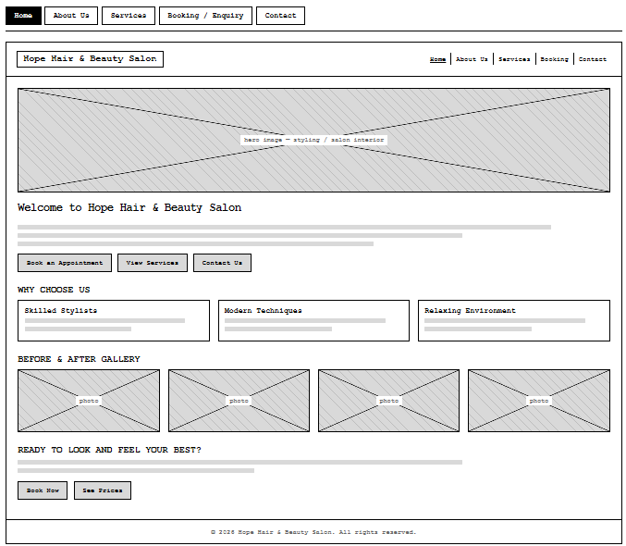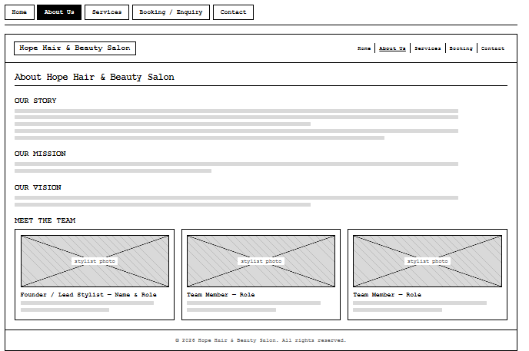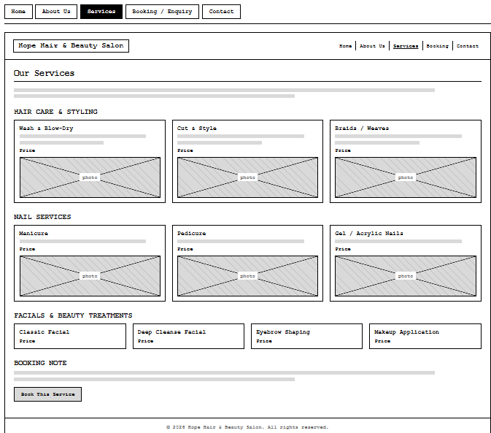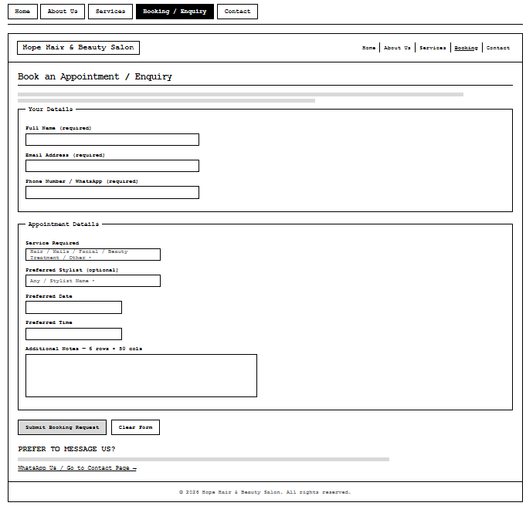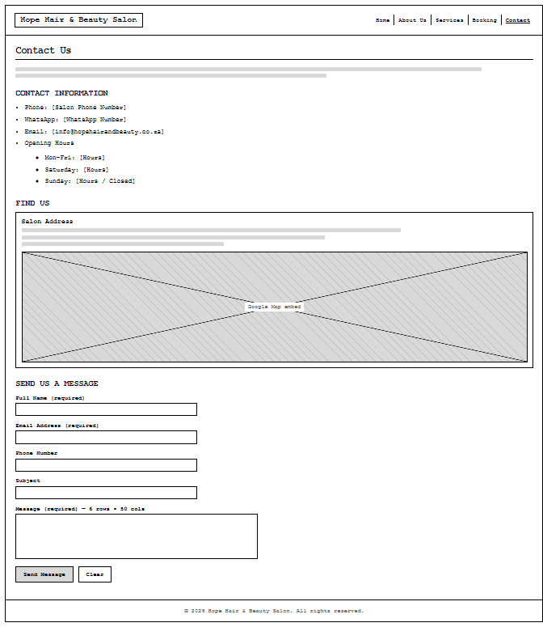

- Technical Requirements
Built with HTML5, CSS3 and JavaScript. A simple CMS (such as WordPress) will allow easy service and price updates. Hosting will use a reliable South African provider with SSL. Recommended domain: hopehairandbeauty.co.za. Integrations include Google Maps, online booking tools and basic analytics.

- Timeline and Milestones
Approximate 8 - 10 week schedule:
- Weeks 1–2: Content collection and wireframes
- Weeks 3–4: Visual design and feedback
- Weeks 5–7: Development and CMS setup
- Week 8: Testing
- Week 9: Launch
- Week 10: Handover and support
8. Budget
Estimated first-year costs (South African rates):
- Domain: R150–R250 per year
- Hosting: R100–R250 per month
- Design and development: R12 000–R25 000
- Photography: R3 000–R6 000
- Annual maintenance: R2 000–R4 000
Total first-year estimate: R18 000–R35 000.

  - References
HubSpot, 2025. 24 Hair Salon Website Design Examples We Love [+ How To Make Your Own]. Available at: https://blog.hubspot.com/website/hair-salons-websites [Accessed 14 August 2026].
Juicy Designs, 2025. Website Creation Cost in South Africa: Full Picture. Available at: https://www.juicydesigns.co.za/blog/website-creation-cost-south-africa/ [Accessed 14 August 2026].
Local Brand Hub, 2026. Salon Website Design: Principles That Convert. Available at: https://localbrandhub.com/blog/salon-website-design [Accessed 14 August 2026].
Style Me Up Digital, 2026. The Complete Guide to Local SEO for Hair Salons in 2026. Available at: https://www.stylemeupdigital.com/blog-post/complete-guide-local-seo-hair-salons-2026 [Accessed 14 August 2026].
Elevate Web Design, 2026. Salon Website Design Examples That Actually Book Appointments. Available at: https://elevatewebdesign.ca/blog/salon-website-design-examples [Accessed 14 August 2026]

